Adhithya Vel M V | 2668807

Portfolio work

CN 4005: Mental Wealth: Professional Life 1

(IT Project Pitching)

SCHOOL OF ARCHITECTURE,

COMPUTING &ENGINEERING

INDIVIDUAL

Assignment

May 06, 2024

Table of Contents

Task 1 3

Initial Career Development Planner 3

Email Evidence 7

Initial CV 8

Task 2: 9

Individual Time Management Plan 9

TASK 6: 10

Final self-evaluation 10

Updated CV 15

# Task 1

## Initial Career Development Planner

**IDENTIFY**

Using the steps provided below, create a short personal mission statement, summarising your values, interests, strengths, and career goals.

**Step 1: Identify Your Core Values**

*Example: Equality, diversity and inclusion, social impact*

Integrity, Responsibility, Curiosity, Teamwork, Open-mindedness along with Equality, Diversity and Social Impact

**Step 2: Define Your Motivating Interests**

*Example: Mental health and support for young adults in the community.*

Academic Excellence and Passion for learning, Personal development- (Leadership qualities and Entrepreneurship) along with Fitness goals

**Step 3: Showcase Your Unique Strengths**

**Example:** *A degree in Psychology, personal experiences with Mental Health, and the ability to build rapport with disadvantaged young people.*

Ability to think creatively and find unique solutions to complex problems, Various experience where I could showcase my research excellence

**Step 4: Craft Your Personal Mission Statement**

Remember, your personal mission statement should reflect your genuine aspirations and potential. Take your time to create a statement that truly represents you.

*Example: I strive to create and inclusive society through education and advocacy, while empowering disadvantaged young adults with the tools and support they need for mental well-being.*

Your Personal Mission Statement:

Live with passion, learn from failure, and inspire others

**EXPLORE**

1. Complete the table provided listing relevant experience (including from your work, studies, and hobbies etc.) to evidence the skills gained.

|  |  |
| --- | --- |
| Relevant Experience | Skills Gained |
| *Example: Temporary job over two summer holidays as a market research interviewer. Marketing module completed as part of my degree studies (12 months) – identifying, anticipating, and satisfying customer requirements profitably.* | *Marketing Skills* |
| I took part in debate competition | Public speaking, Critical Thinking |
| Took part in story-telling competitions | Creativity, Communication |
| Volunteer in cleaning pathway of a lake | Teamwork and Collaboration |
| Click or tap here to enter text. | Click or tap here to enter text. |

2. Considering the skills that you listed above, reflect, and write down any additional key skills required for your chosen industry.

***Tip:*** *The* [*Prospects website*](https://www.prospects.ac.uk/job-profiles) *is a great resource to find job profiles and their associated skills requirements.*

|  |
| --- |
| Continuous learning and adaptation to new technologies.  Being able to quickly problem-solve in difficult circumstances  Conducting research to gather information and evidence to support your arguments |

**DEVELOP**

Using one of the feedback methods discussed and below, seek feedback on elements of your employability toolkit and reflect on how you will use this feedback to enhance your toolkit.

How to get feedback:

* [Shortlist Me (Interview Skills)](https://go.shortlister.com/marketplace/uniofeastlondon)
* Trusted family, friend, or mentor
* Professional network
* Career Zone Advisor
* [CareerSet](https://careerset.com/uel) (CV and Cover Letter)

|  |  |
| --- | --- |
| Element in Employability Toolkit | Feedback received |
| Interview skills | I should practice speaking confidently |
| CV / Portfolio | I should ensure to include a short summary, my studies, any relative experiences and later on add some hobbies & achievement that can show your personality. |
| Cover Letter | Before creating a Cover Page I should thoroughly go through the job description and mention why you're fit for the position by emphasizing your skills and experiences. |
| Digital Platforms | To create and utilize digital platforms such as LinkedIn to build a professional profile attracting recruiters. |
| Business Case (if starting your own business) | Click or tap here to enter text. |

**APPLY**

Identify the best platform/s for you to create or enhance your digital profile and build your profession network.

|  |
| --- |
| Example: LinkedIn, Twitter  LinkedIn: For showcasing your skills and achievements and making an online presence and attracting job recruiters.  Click or tap here to enter text. |

**Building connections with people you don’t know.**

**Rule of thumb:** If they aren’t your family or friend, you should always personalise your invitation. Always make sure to write an accompanying message that tells them a little bit about yourself, your background, and your reason for wanting to connect with them.

If you come across somebody in a field you’re interested in and their profile catches your eye, you can always reach out and introduce yourself.

**You can use this formula to help you:**

Hi Andrew,

I just came across your profile, and I am really interested in the **AI tech analyst** role at EasyA. I’m just starting out in my career, and I’d like to gain some experience at the “Ripple Blockchain”. It would be great to connect with you and perhaps ask a few questions.

Kind regards

Adhithya Vel

Or perhaps they were a speaker or facilitator at an event you attended. In which case, use this formula:

Hi Avishek,

I enjoyed hearing your ideas and perspectives at **Accenture AI & Sustainability**. Thank you for sharing these – I learned a lot! I'm just starting out in my career. It would be great to connect with you and perhaps ask a few questions about **Team Management** and gain insights into your career.   
Kind regards,   
Adhithya Vel

## Email Evidence

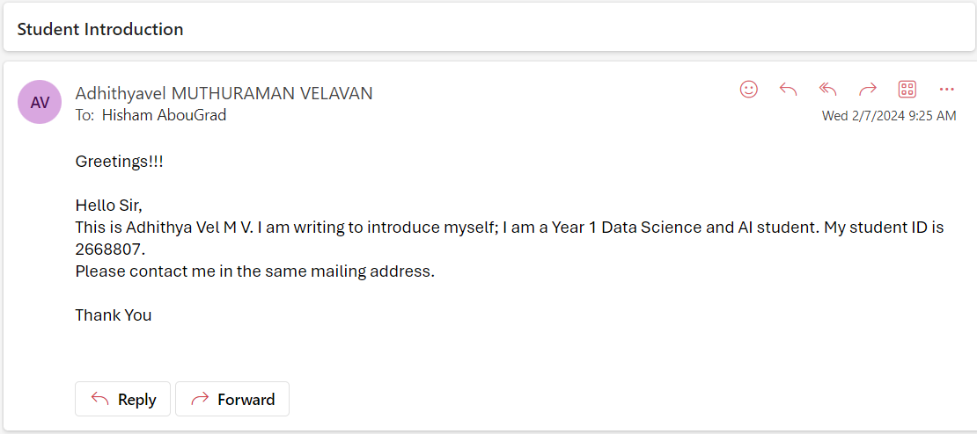

## Initial CV

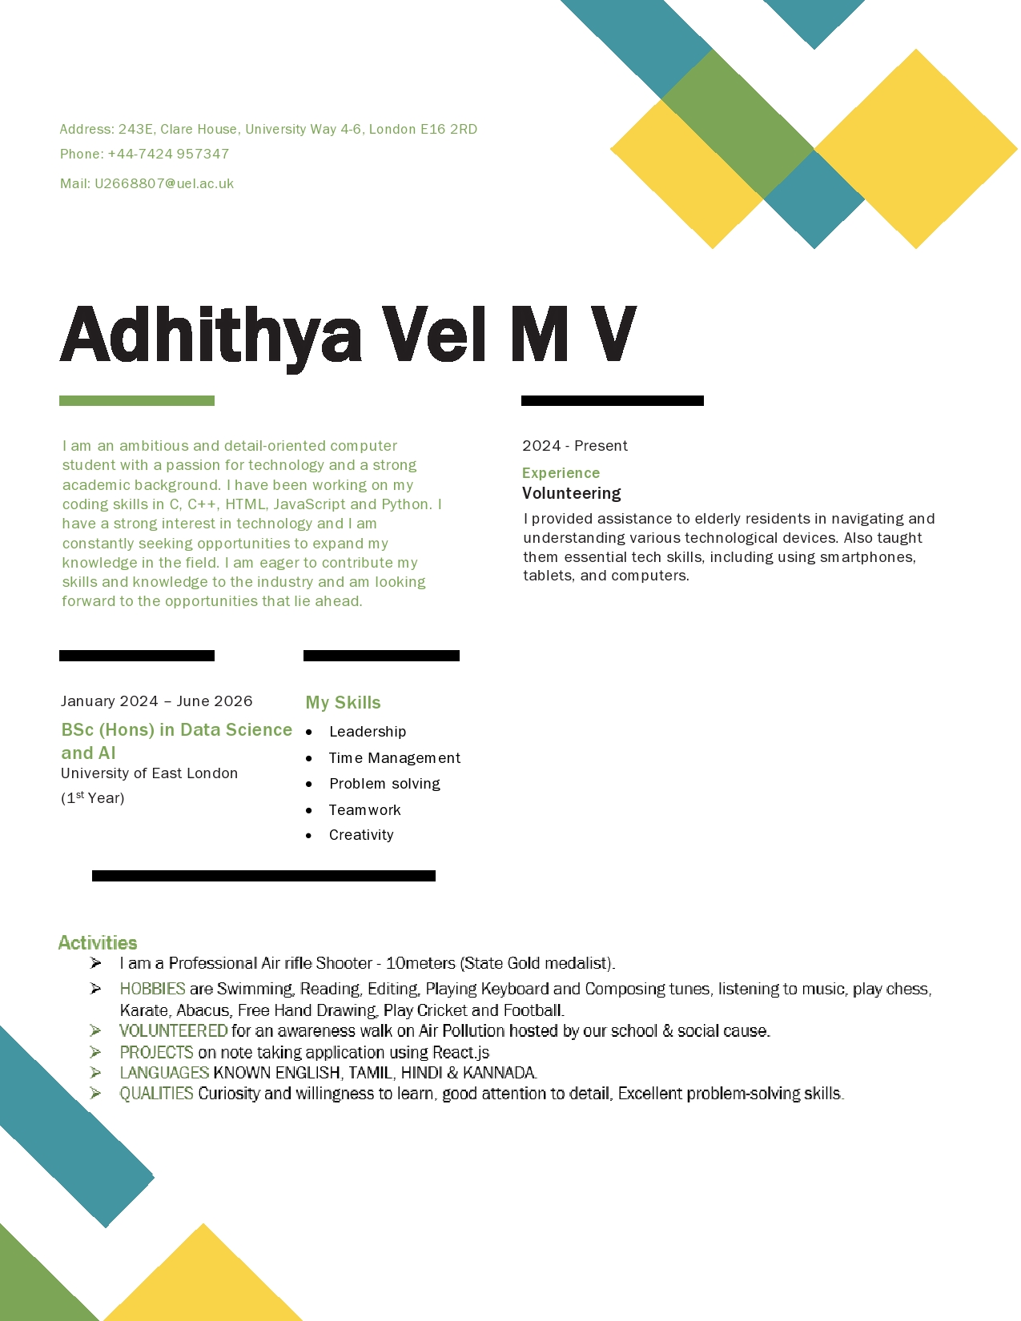

# Task 2:

## Individual Time Management Plan

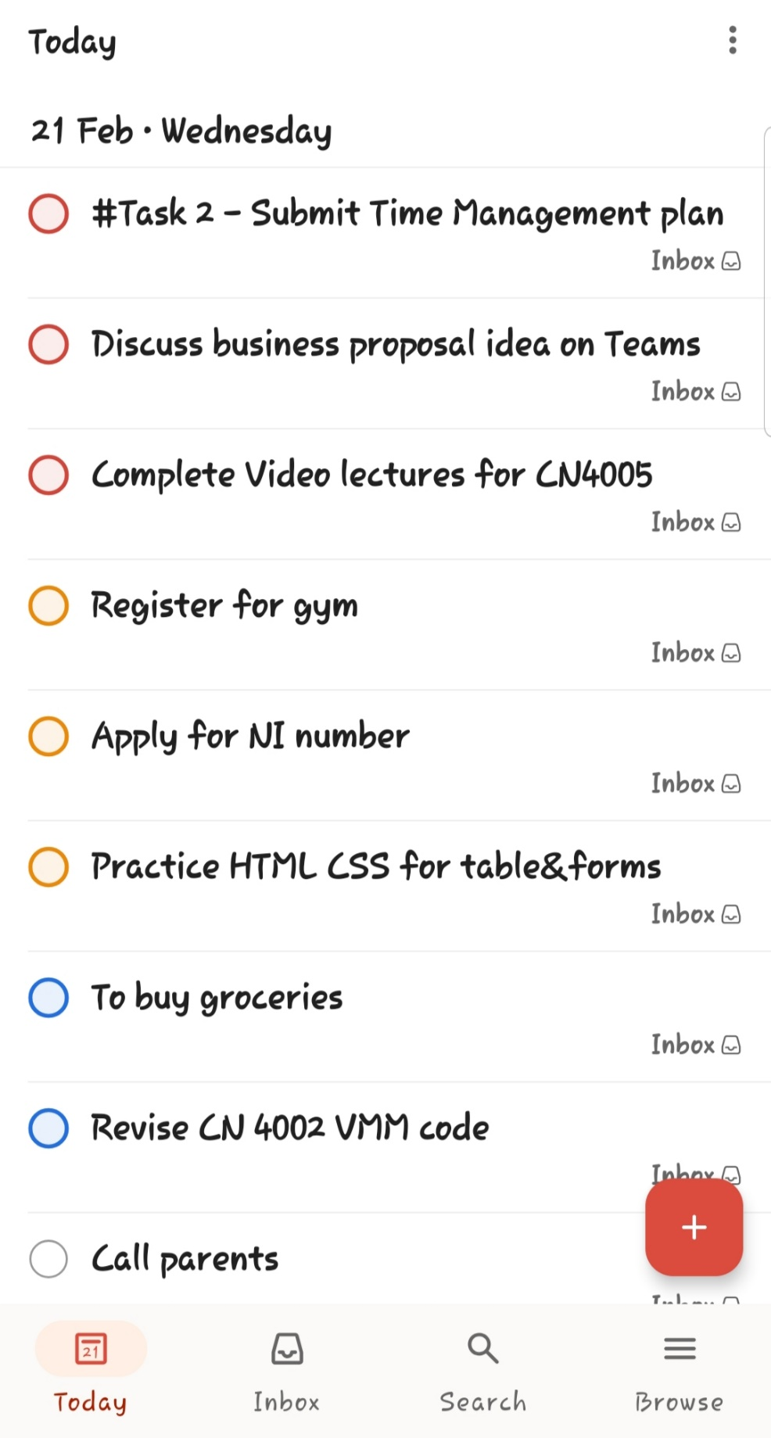

# TASK 6:

## Final self-evaluation

**IDENTIFY**

Using the steps provided below, create a short personal mission statement, summarising your values, interests, strengths, and career goals.

**Step 1: Identify Your Core Values**

*Example: Equality, diversity and inclusion, social impact*

My core values revolve around integrity, being honest and upholding moral principles. Responsibility that guides my decisions and commitment to my duties. Curiosity that fuels my passion to seek knowledge and discover. Open-mindedness that encourages me to accept diverse opinions and embrace opportunities for learning and growth.

**Step 2: Define Your Motivating Interests**

*Example: Mental health and support for young adults in the community.*

I am interested in using artificial intelligence, my academic excellence and passion for learning will help me achieve the role of machine learning engineer.

**Step 3: Showcase Your Unique Strengths**

**Example:** *A degree in Psychology, personal experiences with Mental Health, and the ability to build rapport with disadvantaged young people.*

Ability to think creatively and find unique solutions to complex problems, Various experience where I could showcase my research excellence. I showcased these strengths in our group project where I managed the team, I helped my team in brainstorming sessions etc.

**Step 4: Craft Your Personal Mission Statement**

Remember, your personal mission statement should reflect your genuine aspirations and potential. Take your time to create a statement that truly represents you.

*Example: I strive to create and inclusive society through education and advocacy, while empowering disadvantaged young adults with the tools and support they need for mental well-being.*

Your Personal Mission Statement:

My personal mission is to become a machine learning engineer, leveraging my passion for technology to create innovative solutions that address real-world challenges. My aim is to make positive impact in the field of machine learning. Where I create a more sustainable and inclusive future, where technology serves as a force for good in addressing global challenges.

**EXPLORE**

1. Complete the table provided listing relevant experience (including from your work, studies, and hobbies etc.) to evidence the skills gained.

|  |  |
| --- | --- |
| Relevant Experience | Skills Gained |
| *Example: Temporary job over two summer holidays as a market research interviewer. Marketing module completed as part of my degree studies (12 months) – identifying, anticipating, and satisfying customer requirements profitably.* | *Marketing Skills* |
| I took part in EasyA x Ripple Hackathon | Problem solving, Critical Thinking, Networking |
| By being the Team Leader I managed my team’s Business proposal report and presentation | Leadership, Creativity, Time Management, Presentation Skills, Teamwork and Collaboration |
| Volunteer in helping and assisting elderly with tech | Patience, Communication, Teaching, Cultural Sensitivity and Respect |
| Click or tap here to enter text. | Click or tap here to enter text. |

2. Considering the skills that you listed above, reflect, and write down any additional key skills required for your chosen industry.

***Tip:*** *The* [*Prospects website*](https://www.prospects.ac.uk/job-profiles) *is a great resource to find job profiles and their associated skills requirements.*

|  |
| --- |
| Advance coding and Programming skills.  Efficient in Machine Learning Algorithms, Data Preprocessing and Cleaning  Strong Foundation in Maths  Continuous learning and adaptation to new technologies.  Proficiency in Deep Learning, Software Engineering  Being able to quickly problem-solve in difficult circumstances |

**DEVELOP**

Using one of the feedback methods discussed and below, seek feedback on elements of your employability toolkit and reflect on how you will use this feedback to enhance your toolkit.

How to get feedback:

* [Shortlist Me (Interview Skills)](https://go.shortlister.com/marketplace/uniofeastlondon)
* Trusted family, friend, or mentor
* Professional network
* Career Zone Advisor
* [CareerSet](https://careerset.com/uel) (CV and Cover Letter)

|  |  |
| --- | --- |
| Element in Employability Toolkit | Feedback received |
| Interview skills | I should practice speaking confidently, clarity in answering questions. Not to deviate from the subject from the answer. |
| CV / Portfolio | Give a heading for each section as it will make your CV more readable. Add tools and programming language that you work on in the above skill section. Instead of writing “experience” multiple times, add a section called Projects/ Work experience. |
| Cover Letter | When writing a cover letter, I incorporate keywords from the job description and emphasize relevant experiences and skills that make me a strong candidate for that position. |
| Digital Platforms | To update my LinkedIn profile with skills learnt from module and a professional summary that effectively highlights my strengths and career objectives. To add a professional photo and banner. To engage with relevant industry groups and connections to expand my. |
| Business Case (if starting your own business) | Click or tap here to enter text. |

**APPLY**

Identify the best platform/s for you to create or enhance your digital profile and build your profession network.

|  |
| --- |
| Example: LinkedIn, Twitter  LinkedIn: For showcasing your skills and achievements and making an online presence and attracting job recruiters. For professional networking, learning new skills and sharing projects and following industry leaders.  GitHub: To showcase coding skills and collaborate with other developers on GitHub. I can share my projects, contribute to open-source initiatives and build your professional network. |

**Building connections with people you don’t know.**

**Rule of thumb:** If they aren’t your family or friend, you should always personalise your invitation. Always make sure to write an accompanying message that tells them a little bit about yourself, your background, and your reason for wanting to connect with them.

If you come across somebody in a field you’re interested in and their profile catches your eye, you can always reach out and introduce yourself.

**You can use this formula to help you:**

|  |
| --- |
| Hi Andrew,  I just came across your profile, and I am really interested in the **AI tech analyst** role at EasyA. I’m just starting out in my career, and I’d like to gain some experience at the “Ripple Blockchain”. It would be great to connect with you and perhaps ask a few questions.  Kind regards Adhithya Vel |

Or perhaps they were a speaker or facilitator at an event you attended. In which case, use this formula:

|  |
| --- |
| Hi Avishek,  I enjoyed hearing your ideas and perspectives at **Accenture AI & Sustainability**. Thank you for sharing these – I learned a lot! I'm just starting out in my career. It would be great to connect with you and perhaps ask a few questions about **Team Management** and gain insights into your career.  Kind regards,  Adhithya Vel |

## Updated CV

